CS-306- Data Communication &Networks



**Project Report**

Complex Engineering Problem

SECTION (A)

Submitted By:

Muhammad Memoon (20-SE-030)

Mohammad Huzaifa (20-SE-045)

Submitted To:

**Ma’am Saima Shaheen**

# HITEC UNIVERSITY, TAXILA

Title: Complex Engineering Problem

1. **ABSTRACT:**

Computer networks have a significant impact on the working of an organization. Universities depend on the proper functioning and analysis of their networks for education, administration, communication, e-library, automation, etc. An efficient network is essential to facilitate the systematic and cost-efficient transfer of information in an organization in the form of messages, files, and resources. The project provides insights into various concepts such as topology design, IP address configuration, and how to send information in the form of packets to the wireless networks of different areas of a University.

The aim of this project is to design the topology of the university network using the software Cisco Packet Tracer with the implementation of wireless networking systems. This university network consists of the following devices:

1) Router (1941)

2) Switches (2960-24TT)

3) Email server

4) DNS server

5) WEB server (HTTP)

6) Wireless Device (Access Point)

7) PCs

8) Laptops

9) Smartphones

The design includes the following parts of the University:

* Israr Block (Teacher Cabin , Coordinator office, Labs)
* Sir Syed Block (Teacher office, Simulation labs)
* Boys Hostel
* Girls Hostel
* Secretariat
* Controller exam Office
* Registrar Office
* Account Office
* DSA Office
* Library

TABLE OF CONTENTS

|  |  |
| --- | --- |
| 1. | Cover Page |
| 3. | Abstract |
| 4. | Table of Contents |
| 5. | Chapter 1: Introduction |
| 6. | Chapter 2: Literature Review |
| 7. | Chapter 3: Work Done |
| 8. | Chapter 4: Results and Discussion |
| 9. | Chapter 5: Conclusions and Future Work |
| 10. | References |

1. **INTRODUCTION:**

The word “digital” is very significant in today’s world, with an increase in the development of technology the entire world is moving towards the digital era. The educational institution plays an important role in this digitalization; hence the Hitec university should adapt to digital means of networking as well and become a “digital campus”. University networking becomes an important part of campus life and provides the main way for teachers and students to access educational resources, which gives an important platform to exchange information. As laptops and intelligent terminals are widely used, demand for access to information anytime and anywhere has become more and more urgent, but traditional cable networks cannot meet this requirement. Then wireless network construction becomes necessary and essential. The wireless network is one of the important components of a digital campus and wisdom campus. It provides an efficient way to explore the internet with a mobile terminal for teachers and students regardless of cables and places.

1. **LITERATURE REVIEW:**

* What is Packet Tracer?

Packet Tracer is a cross-platform visual simulation tool designed by Cisco Systems that allows users to create network topologies and imitate modern computer networks. The software allows users to simulate the configuration of Cisco routers and switches using a simulated command-line interface. Packet Tracer makes use of a drag-and-drop user interface, allowing users to add and remove simulated network devices as they see fit. The software is mainly focused on Certified Cisco Network Associate Academy students as an educational tool for helping them learn fundamental CCNA concepts. Previously students enrolled in a CCNA Academy program could freely download and use the tool free of charge for educational use.

* Router

A router is a device like a switch that routes data packets based on their IP addresses. The router is mainly a Network Layer device. Routers normally connect LANs and WANs together and have a dynamically updating routing table based on which they make decisions on routing the data packets. Router divides broadcast domains of hosts connected through it.

* Switch

A network switch (also called switching hub, bridging hub, officially MAC bridge is networking hardware that connects devices on a computer network by using packet switching to receive and forward data to the destination device. A network switch is a multiport network bridge that uses MAC addresses to forward data at the data link layer (layer 2) of the OSI model. Some switches can also forward data at the network layer (layer 3) by additionally incorporating routing functionality. Such switches are commonly known as layer-3 switches or multilayer switches.

* Network Packet

A network packet is a formatted unit of data carried by a packet-switched network. A packet consists of control information and user data, which is also known as the payload.

* Server

A server is a computer or system that provides resources, data, services, or programs to other computers, known as clients, over a network. In theory, whenever computers share resources with client machines they are considered servers. There are many types of servers, including web servers, mail servers, and virtual servers.

Many networks contain one or more of the common servers. The servers used in our project are as follows:

* DNS Server

DNS stands for Domain Name System servers which are application servers that provide a human-friendly naming method to the user computers in order to make IP addresses readable by users. The DNS system is a widely distributed database of names and other DNS servers, each of which can be used to request an otherwise unknown computer name. When a user needs the address of a system, it sends a DNS request with the name of the desired resource to a DNS server. The DNS server responds with the necessary IP address from its table of names.

* WEB Server

One of the widely used servers in today’s market is a web server. A web server is a special kind of application server that hosts programs and data requested by users across the Internet or an intranet. Web servers respond to requests from browsers running on client computers for web pages, or other web-based services.

* EMAIL Server

An e-mail server is a server that handles and delivers e-mail over a network, using standard email protocols. For example, the SMTP protocol sends messages and handles outgoing mail requests. The POP3 protocol receives messages and is used to process incoming mail. When you log on to a mail server using a webmail interface or email client, these protocols handle all the connections behind the scenes.

* Wireless Network

A wireless network broadcasts an access signal to the workstations or PCs. This enables mobility among laptops, tablets, and PCs from room to room while maintaining a firm network connection continuously. A wireless network also presents additional security requirements.

* Ethernet

This is the backbone of our network. It consists of the cabling and is typically able to

transfer data at a rate of 100mb/s. It is a system for connecting a number of computer systems to form a local area network, with protocols to control the passing of information and to avoid simultaneous transmission by two or more systems. Among the different types of ethernet, we have used Gigabit Ethernet, which is a type of Ethernet network capable of transferring data at a rate of 1000 Mbps and fast Ethernet is a type of Ethernet network that can transfer data at a rate of 100 Mbps.

* Computing Device

Computing devices are the electronic devices that take user inputs, process the inputs, and then provide us with the end results. These devices may be Smartphones, PC Desktops, Laptops, printer, and many more.

* Internet Protocol

Internet Protocol (IP) is one of the fundamental protocols that allow the internet to work. IP addresses are a unique set of numbers on each network and they allow machines to address each other across a network. It is implemented on the internet layer in the IP/TCP model

1. **WORK DONE:**

In order to make our project understandable, we have divided the content into steps. They are as follows:

1. **Software and hardware requirements**

Before heading towards the implementation we need to make sure of the following requirements.

* A proper workstation (any mid-high range laptop will suffice).
* Packet Tracer by Cisco

1. **Network Requirements**

Devices Used In The Network

|  |  |
| --- | --- |
| Devices | Quantity |
| 1) Router (1941) | 7 |
| 2) Switches (2960-24TT) | 18 |
| 3) EMAIL server | 1 |
| 4) DNS server | 1 |
| 5) WEB server (HTTP) | 1 |
| 6) Wireless Device (Access Point) | 6 |
| 7) PCs | 53 |
| 8) Laptops | 2 |
| 9) Smartphones | 2 |

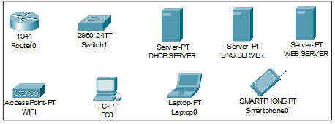

Figure: Devices Used in network

1. **Implementation and Flow Diagram**

* To design the network of the university we initially started by placing the core devices into the frame.
* Firstly, we placed the **main router** at the center of the university outline, which was further connected to the **server switch** using the gigabit ethernet port with copper straight-through cable and sub routers (**Israr Block router, Secretariat, Sir syed block router and hostel router**) using the serial port with serial DCE cable at the hostel area and campus area respectively.
* The server switch was further connected to the **EMAIL, DNS, and WEB** servers respectively.
* Campus router was connected to the campus switch which was further connected with **DCCN, Computing, Ai and database Labs** Switch.
* The Secretariat router is further connected to the switch of the Nusrat and Iqbal auditorium and the Registrar and account office.
* The wireless access points were then connected to computing devices (PCs, laptops, and smartphones).
* Similarly, the hostel router was connected to the hostel switch which was further connected with the wireless access point of boys and girls.
* The wireless access points were then connected to the computing devices (PCs, laptops, and smartphones), every area has a dedicated access point which can only be connected with the help of a password.
* All these connections are made through ethernet ports (gigabit ethernet and fast ethernet) using copper straight-through cables.

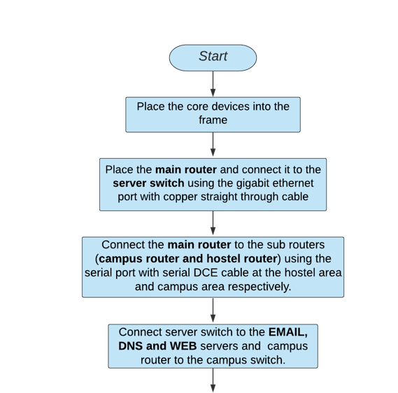

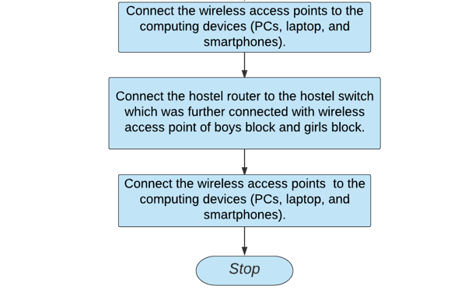

This is flow diagram for a better understanding of the steps mentioned above.

1. **Configuring IP Addresses**

* Main Router configuration

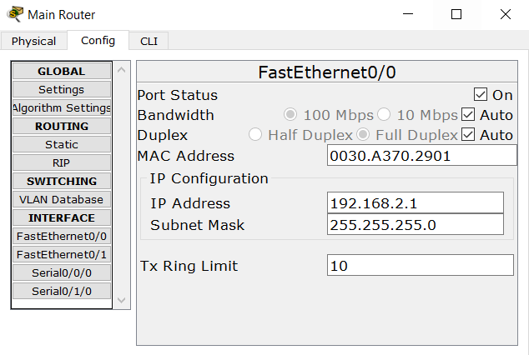

* DNS SERVER

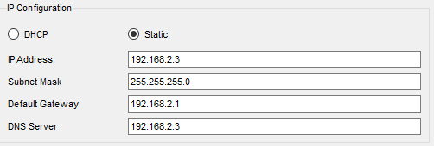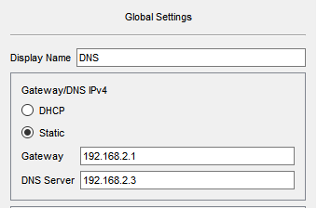

* WEB SERVER

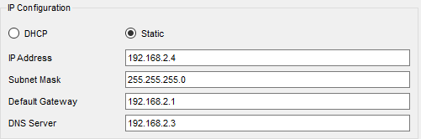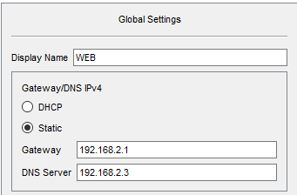

* EMAIL SERVER

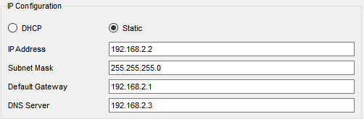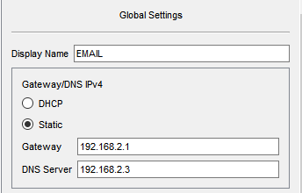

**Ip Address Classification:**

**Israr Block:**

IP Address are as follows

192.168.3.1 for Router

From **192.168.3.3 to 192.168.3.6**

From 192.168.5.3 to 192.168.5.22 for PCs

Subnet Mask- 255.255.255.0

Default Gateway- 192.168.3.1

DNS Server- 192.168.2.2

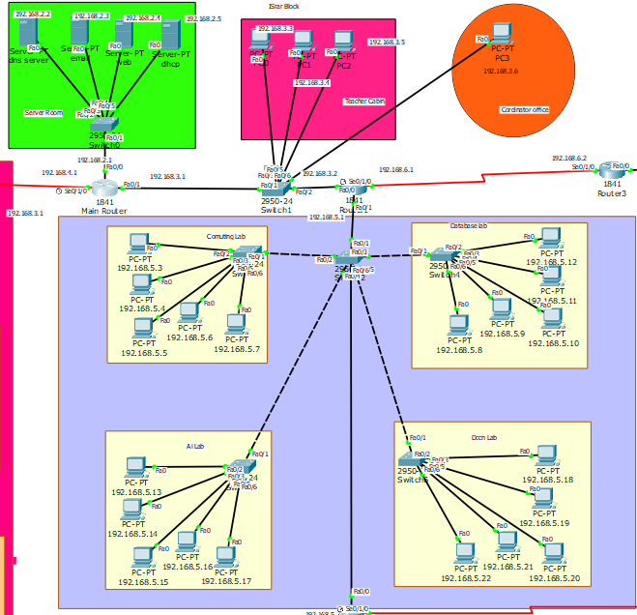

**Sir Syed Block:**

192.168.8.1 and 192.168.8.2 for Router

From **192.168.8.3 to 192.168.8.15 for Pcs**

Subnet Mask- 255.255.255.0

Default Gateway- 192.168.5.2

DNS Server- 192.168.2.2

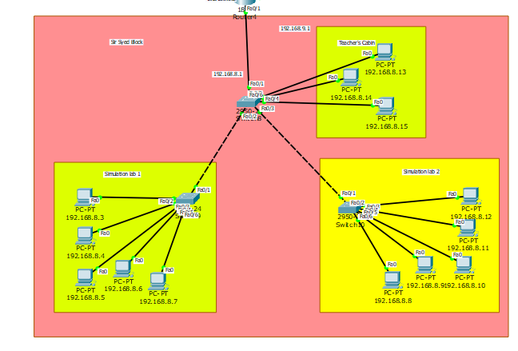

**Secretariat:**

192.168.4.1 and 192.168.4.2 for Router

From **192.168.13.3 to 192.168.13.14 for Pcs**

Subnet Mask- 255.255.255.0

Default Gateway- 192.168.13.1

DNS Server- 192.168.2.2

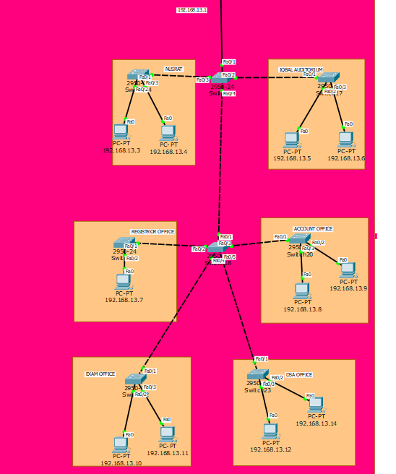

* WIRELESS ACCESS POINT

|  |  |
| --- | --- |
| SSID | Password |
| 1)csdepartment | 12345678 |
| 2)Nusrat | 12345678 |
| 3)library | 12345678 |
| 4)boyshostel | 12345678 |
| 5)girlshostel | 12345678 |
| 6)sir syed student | 12345678 |
| 7)csfaculty | 12345678 |

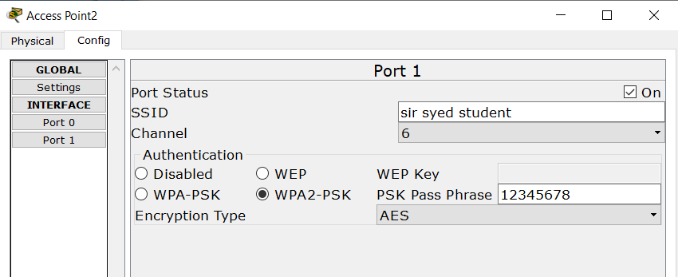

1. **Securing the network**

Passwords are used in accessing the router and all the wireless networks (mentioned in step 5 wireless access point) to make the access limited to University authorized users only.

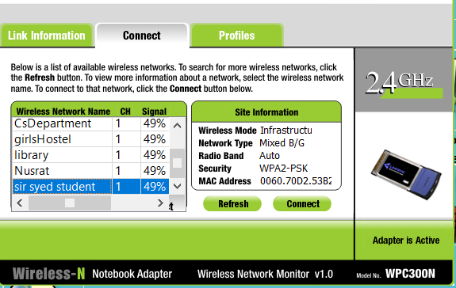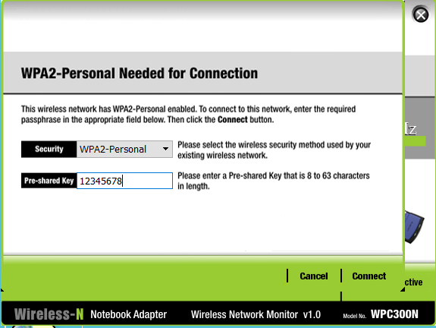

**Connectivity of wireless network on computing devices**

1. **RESULT & DISCUSSION:**

Finally, we have combined all the steps as mentioned in chapter 3 (work done) and implemented the desired wireless network for University. We have the complete network providing various facilities to the teaching staff, non-teaching staff, and students.

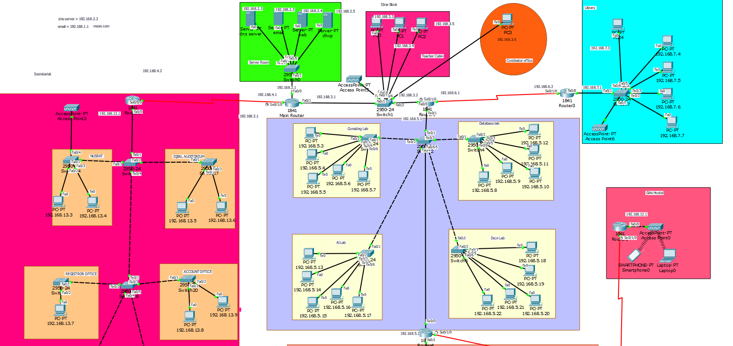

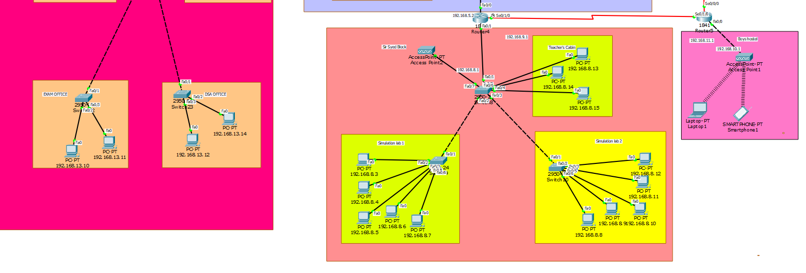

* Ping Test: Network connectivity and communication can be tested using the ping command, followed by the domain name or the IP address of the device (equipment) whose connectivity one wishes to verify.

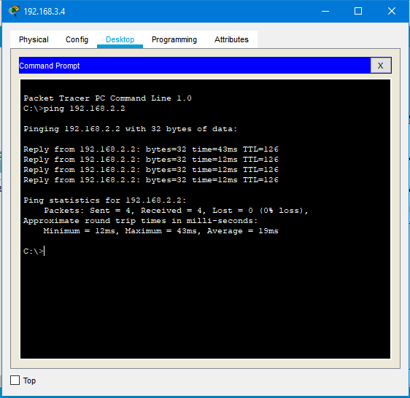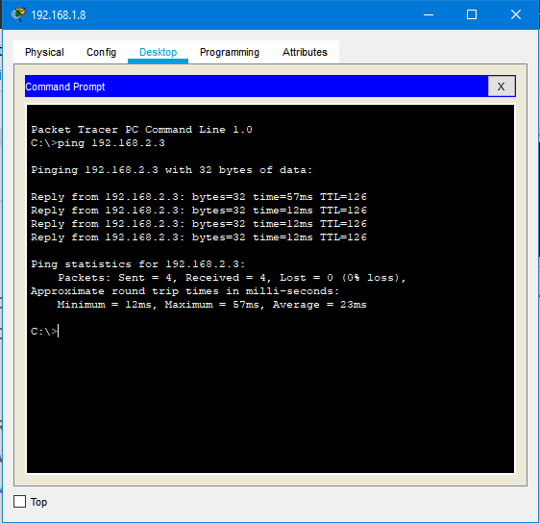

Ping Test for EMAIL server

1Ping test for web

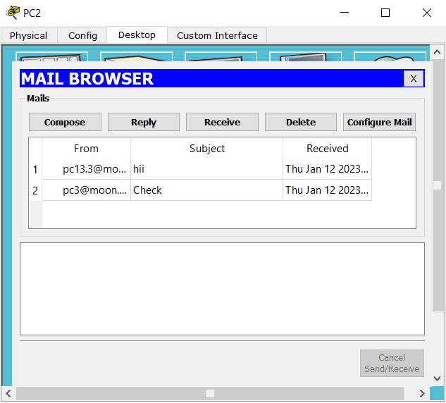

Email received on device sent through EMAIL server

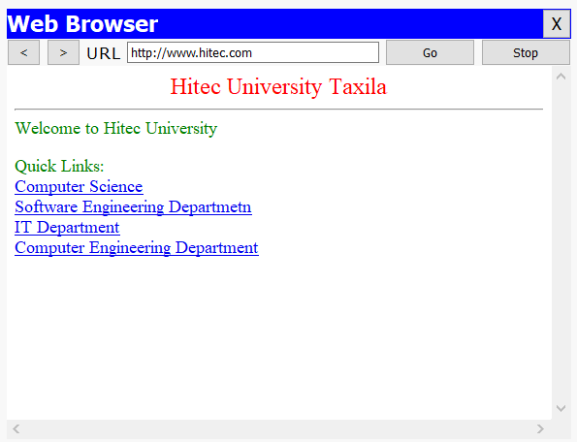

Hitec Website accessed through web browser

1. **CONCLUSION AND FUTURE WORK:**

* Conclusion

In this project, we designed University Network using Cisco Packet Tracer that uses a networking topology implemented using servers, routers, switches, and end devices in a multiple area network. We have covered all the necessary features that are required for a network to function properly. We have included a DNS server and a web server for establishing a smooth communication system between different areas of our network and specifically for the communication between students and teachers. We have included an email server to facilitate intra university communication through emails within the domain. We have used console passwords and ssh protocol to ensure a safe and secure transfer of data.

* Future Work

The configuration and specifications are for the initial prototype and can further be developed and additional functionality can be added

1. REFERENCES

[1] https://www.netacad.com/courses/packet-tracer

[2]<https://www.paessler.com/it-explained/server>

[3]<https://computernetworking747640215.wordpress.com/2018/07/05/secure-shell-ssh-configuration-on-a-switch-and-router-in-packet-tracer/>

[4]<http://router.over-blog.com/article-how-to-configure-cisco-router-password-106850439.html>

[5]<https://www.cognoscape.com/benefits-going-wireless/>